SOFTWARE PROJECT 2
Project 3 — Prescriptive Analytics
Allocating a Road-Safety Budget Across US States
Dataset: car_crashes.csv (51 records)
Prepared by: Dhanesh kumar
Course: software project 2
Date: July 13, 2026

1. Introduction & Business Objective
Prescriptive analytics goes one step further than predictive analytics: instead of only forecasting an outcome, it recommends the best action to take given limited resources and real constraints. This project poses a resource-allocation problem: a national road-safety agency has state-level crash data and a fixed budget for a targeted safety campaign addressing speeding and drunk driving. The question is not “which states have the most crashes?” (descriptive) or “how many crashes will a state have?” (predictive) — it is: given that not every state can be funded, exactly which states should receive funding, and how much, to maximize the total reduction in crashes?

2. Dataset Description
The analysis uses the "car_crashes" dataset — one row per US state plus DC (51 records), a third dataset distinct from Projects 1 and 2 — recording the crash rate per billion miles driven, the share of fatal-crash drivers who were speeding or alcohol-impaired, and each state's average insurance premium and losses.
Column | Description
total | Crashes per billion miles driven
speeding, alcohol | % of fatal-crash drivers who were speeding / alcohol-impaired
not_distracted | % of fatal-crash drivers who were NOT distracted
no_previous | % of fatal-crash drivers with NO prior accidents
ins_premium, ins_losses | Average insurance premium and losses for the state

3. Methodology

3.1 Importing Libraries and Loading the Data
Alongside the standard pandas/numpy/matplotlib/seaborn stack, scikit-learn provides the Linear Regression model and cross-validation tools, and SciPy's linprog function solves the linear program at the core of the prescriptive recommendation.

3.2 Data Cleaning and Preprocessing
As a small, well-maintained reference dataset, car_crashes has no missing values and no negative percentages, but the standard checks are run rather than assumed.

3.3 Duplicate Removal
No duplicate rows are found in this 51-row dataset.

3.4 Feature Selection
The state abbreviation is an identifier, not a predictive feature — useful for labeling results but meaningless as numeric model input — so it is excluded from the regression's feature set while being kept in the DataFrame for readability.

3.5 Encoding Categorical Attributes
The dataset has no natural categorical column beyond the state code, so one is engineered: each state is mapped to its official US Census Bureau region (Northeast / Midwest / South / West) and one-hot encoded, enabling a regional breakdown in the exploratory analysis.

4. Exploratory Data Analysis
Alcohol and speeding involvement both correlate positively with total crash rate, matching intuition — these are the two behavioral factors a public-awareness campaign can realistically influence. The South shows the highest average crash rate by region, while the Northeast shows the lowest.
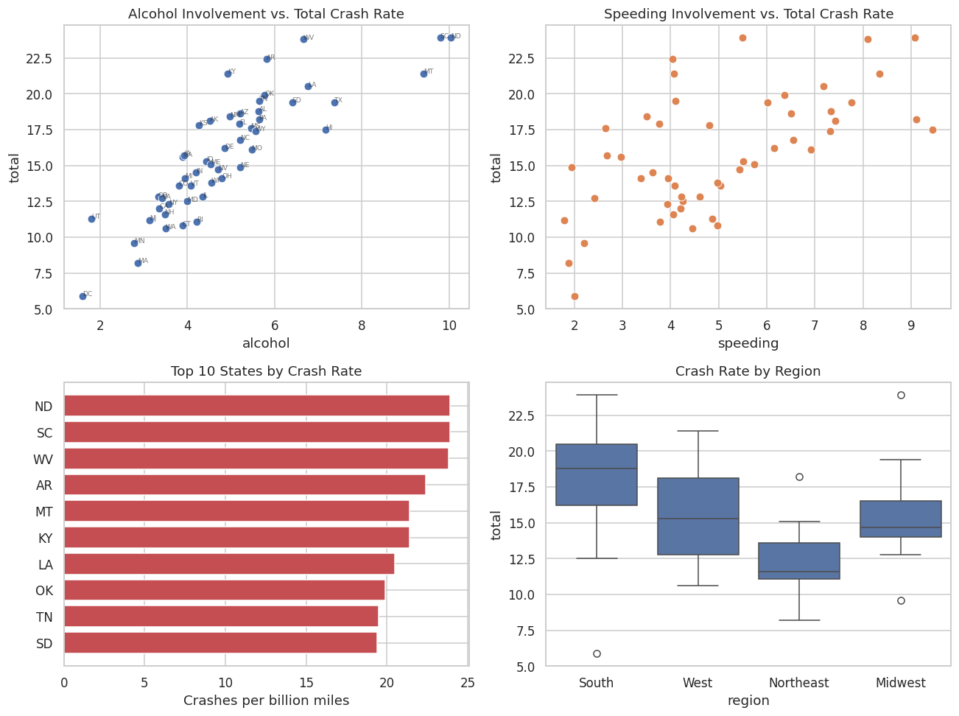
Figure 1. Alcohol/speeding vs. crash rate, the ten highest-risk states, and crash rate by region.

5. Model Building & Evaluation

5.1 Predictive layer — what drives crash rate?
With only 51 rows, a single train/test split would leave a test set too small to trust, so the model is evaluated with 5-fold cross-validation instead — a more reliable approach for small datasets. A linear regression using all four behavioral features achieves a mean cross-validated R² of 0.91, which is strong for cross-sectional, state-level social data of this kind.
A methodological note on collinearity: in the full 4-variable model, the coefficient on speeding comes out slightly negative even though speeding correlates positively with crash rate on its own — a classic multicollinearity symptom, since speeding overlaps enough with no_previous and alcohol that the full model's coefficients describe partial effects holding the other variables constant. Since the campaign can only target speeding and alcohol anyway, a separate, dedicated two-variable model (R² = 0.73) is fit using just those two predictors for the prescriptive step below — both coefficients come out positive, as expected, avoiding an artifact from variables the campaign does not target.

5.2 Prescriptive layer — optimal budget allocation
Each state's “actionable risk score” is defined as the dedicated model's fitted contribution of speeding and alcohol involvement. Campaign cost is assumed to scale with each state's insurance-premium level (a stated simplifying assumption, used as a proxy for market/media cost). With a total budget covering only 30% of the cost to fund every state, linear programming (SciPy's linprog) determines what fraction of full funding each state should receive to maximize total expected benefit.
Metric | Value
Total cost to fund every state | $45,235
Available budget (30%) | $13,570
Optimal total expected benefit | 229.25
States fully funded | 17
States partially funded | 1 (Ohio)
Greedy benefit-per-dollar heuristic matches LP optimum | Yes
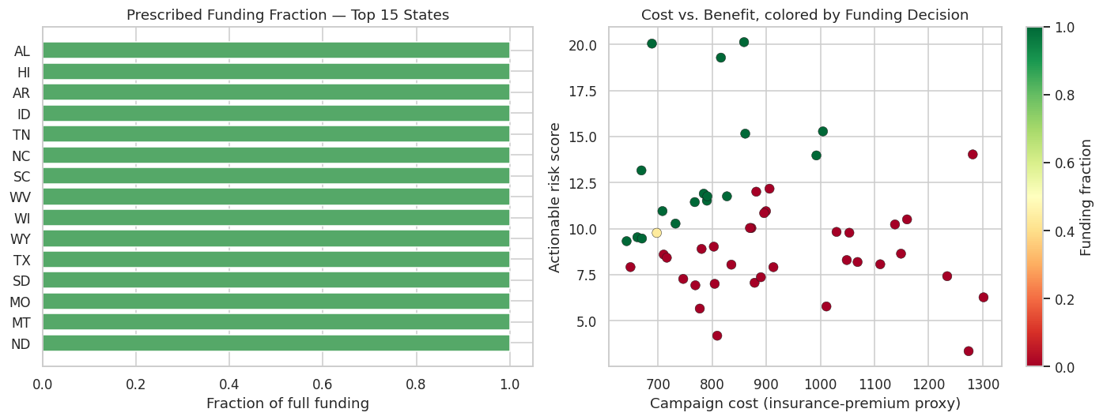
Figure 2. Prescribed funding fraction by state, and the cost-vs-benefit trade-off colored by funding decision.

6. Results Interpretation & Discussion
- The optimizer does not simply fund the states with the highest raw crash rate — it funds the states with the best expected benefit per dollar, and a simple greedy benefit-per-dollar ranking independently confirms the same allocation, validating that the LP found the true optimum for this budget structure.
- Some high-crash-rate states with a high campaign cost receive partial or no funding this round, while some states with more moderate crash rates but a favorable cost profile are funded in full — a counter-intuitive, resource-aware recommendation that distinguishes prescriptive analytics from simply ranking states by risk.
- If more budget becomes available, the same model can be re-solved instantly with an updated budget figure to see exactly which state is funded next: the marginal state at the funding cutoff is the one with the best benefit-per-dollar among those not yet funded.
Limitations stated honestly: the cost proxy (insurance premium) and the assumption that campaign benefit is linear in speeding/alcohol involvement are simplifications made explicit for this exercise; a production version would use actual program-cost estimates and, ideally, a causal (not just correlational) estimate of campaign effectiveness.

7. Conclusion
This project demonstrates a complete prescriptive-analytics workflow: a predictive regression model quantifies how much each behavioral factor drives crash rate, and a linear program then uses those estimates to recommend an optimal, budget-constrained allocation across 51 states — directly answering the resource-allocation question that descriptive or predictive analytics alone could not.

